CC Practicals
- CC- Secure File Sharing Between Cloud Instances Create a cloud-based environment where two virtual machines communicate securely within a virtual network. Implement a mechanism to transfer files between the instances while ensuring proper access permissions.
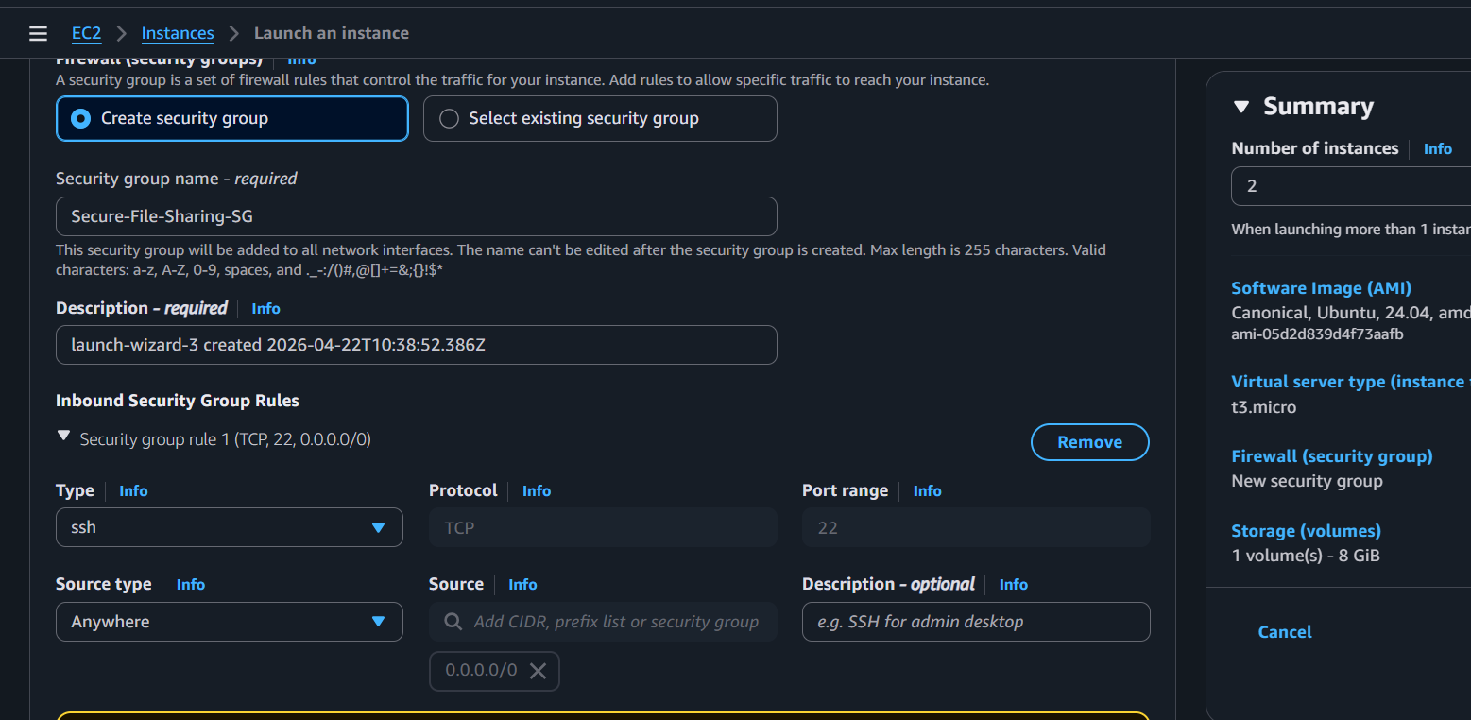

Step 1: Launch 2 Instances at Once
Don't launch them one by one. Do it together so they share everything.
- Go to Launch Instances.
- Number of instances: Set this to 2.
- Key Pair: Select your existing cc-lab-key.
- Network Settings: * Select your Default VPC.
  - Under Firewall, choose "Select existing security group".
  - Select the one named "default". (This group usually allows all traffic between members of the same group automatically).
- Launch.

Step 2: Fix the "Default" Security Group (Only 1 Rule)
The "default" group might not let you in from your house. We need to add one rule so you can talk to them.
- Go to Security Groups in the sidebar.
- Select the default group.
- Click Edit inbound rules and add:
  - Type: SSH | Port: 22 | Source: Anywhere (0.0.0.0/0).
- Save.

1 scp -i vpcprac.pem ubuntu@13.201.62.85
2 icacls.exe "vpcprac.pem" /reset
3 icacls.exe "vpcprac.pem" /grant:r "$($env:USERNAME):(R)"
4 icacls.exe "vpcprac.pem" /inheritance:r

- scp -i vpcprac.pem vpcprac.pem ubuntu@13.201.62.85:~/
2 chmod 400 vpcprac.pem
3 echo "This is a secure file shared between PICT cloud instances." > lab_report.txt
4 scp -i vpcprac.pem lab_report.txt ubuntu@172.31.42.168:~/

For instance 2
ssh -i vpcprac.pem ubuntu@43.205.119.191

1 ls ~/
2 cat ~/lab_report.txt

